Question 1

Entity Relationship Diagram showing how the entities within cheetah deliveries are linked to each other.

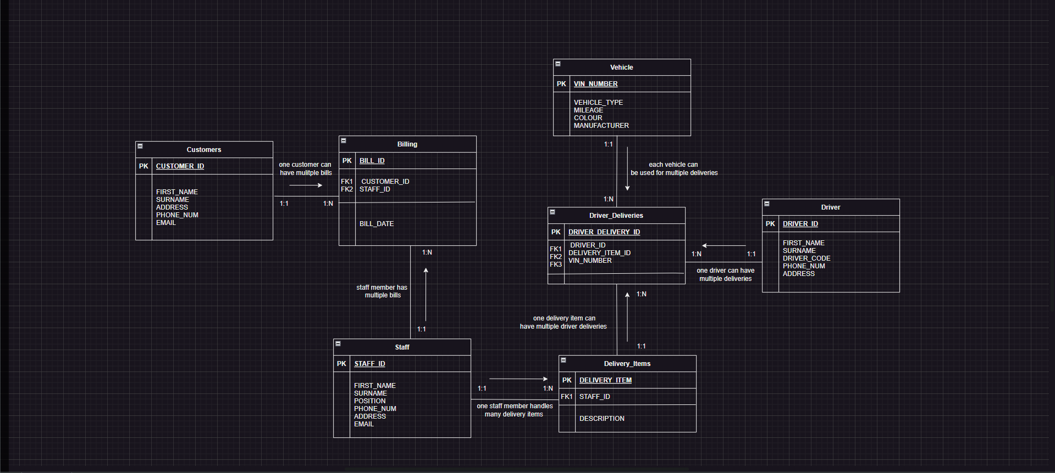

Question 2

-- question 2

--create tables

create table Customers(

CUSTOMER_ID number primary key,

FIRST_NAME varchar2(50),

SURNAME varchar2(50),

ADDRESS varchar2(100),

PHONE_NUM varchar2(15),

EMAIL varchar2(50)

);

select * from Customers;

create table Staff(

STAFF_ID number primary key,

FIRST_NAME varchar2(50),

SURNAME varchar2(50),

POSITION varchar2(50),

PHONE_NUM varchar2(15),

ADDRESS varchar2(100),

EMAIL varchar2(50)

);

select * from Staff;

create table Billing(

BILL_ID number primary key,

CUSTOMER_ID number,

STAFF_ID number,

BILL_DATE date,

foreign key (CUSTOMER_ID) references Customers(CUSTOMER_ID),

foreign key (STAFF_ID) references Staff(STAFF_ID)

);

select * from Billing;

create table Delivery_Item(

DELIVERY_ITEM_ID number primary key,

DESCRIPTION varchar2(100),

STAFF_ID number,

foreign key (STAFF_ID) references Staff(STAFF_ID)

);

select * from Delivery_Item;

create table Driver(

DRIVER_ID number primary key,

FIRST_NAME varchar2(50),

SURNAME varchar2(50),

DRIVER_CODE varchar2(10),

PHONE_NUM varchar2(15),

ADDRESS varchar2(100)

);

select * from Driver;

create table Vehicle(

VIN_NUMBER varchar2(50) primary key,

VEHICLE_TYPE varchar2(50),

MILEAGE number,

COLOUR varchar2(20),

MANUFACTURER varchar2(50)

);

select * from Vehicle;

create table Driver_Deliveries(

DRIVER_DELIVERY_ID number primary key,

VIN_NUMBER varchar(20),

DRIVER_ID number,

DELIVERY_ITEM_ID number,

foreign key (VIN_NUMBER) references Vehicle(VIN_NUMBER),

foreign key (DRIVER_ID) references Driver(DRIVER_ID),

foreign key (DELIVERY_ITEM_ID) references Delivery_Item(DELIVERY_ITEM_ID)

);

select * from Driver_Deliveries;

--insert data

INSERT INTO Customers (CUSTOMER_ID, FIRST_NAME, SURNAME, ADDRESS, PHONE_NUM, EMAIL) VALUES (11011, 'Bob', 'Smith', '18 Water rd', '0877277521', 'bobs@isat.com');

INSERT INTO Customers (CUSTOMER_ID, FIRST_NAME, SURNAME, ADDRESS, PHONE_NUM, EMAIL) VALUES (11012, 'Sam', 'Hendricks', '22 Water rd', '0863257857', 'shen@mcom.co.za');

INSERT INTO Customers (CUSTOMER_ID, FIRST_NAME, SURNAME, ADDRESS, PHONE_NUM, EMAIL) VALUES (11013, 'Larry', 'Clark', '101 Summer lane', '0834567891', 'larc@mcom.co.za');

INSERT INTO Customers (CUSTOMER_ID, FIRST_NAME, SURNAME, ADDRESS, PHONE_NUM, EMAIL) VALUES (11014, 'Jeff', 'Jones', '55 Mountain way', '0612547895', 'jj@isat.co.za');

INSERT INTO Customers (CUSTOMER_ID, FIRST_NAME, SURNAME, ADDRESS, PHONE_NUM, EMAIL) VALUES (11015, 'Andre', 'Kerk', '5 Main rd', '0827238521', 'akerk@mcal.co.za');

INSERT INTO Customers (CUSTOMER_ID, FIRST_NAME, SURNAME, ADDRESS, PHONE_NUM, EMAIL) VALUES (11016, 'Wayne', 'Smith', '13 Water rd', '0877277522', 'ws@isat.com');

INSERT INTO Customers (CUSTOMER_ID, FIRST_NAME, SURNAME, ADDRESS, PHONE_NUM, EMAIL) VALUES (11017, 'John', 'Hendricks', '29 Water rd', '0863257851', 'jhen@mcom.co.za');

INSERT INTO Customers (CUSTOMER_ID, FIRST_NAME, SURNAME, ADDRESS, PHONE_NUM, EMAIL) VALUES (11018, 'Sally', 'Clark', '111 Summer lane', '0834567892', 'sallyc@mcom.co.za');

INSERT INTO Customers (CUSTOMER_ID, FIRST_NAME, SURNAME, ADDRESS, PHONE_NUM, EMAIL) VALUES (11019, 'Bridget', 'Bitterhour', '125 Mountain way', '0612547896', 'bb@isat.co.za');

INSERT INTO Customers (CUSTOMER_ID, FIRST_NAME, SURNAME, ADDRESS, PHONE_NUM, EMAIL) VALUES (11111, 'Nicole', 'Kerk', '175 Main rd', '0827238529', 'nk@mcal.co.za');

INSERT INTO Customers (CUSTOMER_ID, FIRST_NAME, SURNAME, ADDRESS, PHONE_NUM, EMAIL) VALUES (11112, 'Catherine', 'Smith', '19 Water rd', '0877277523', 'cath@isat.com');

INSERT INTO Customers (CUSTOMER_ID, FIRST_NAME, SURNAME, ADDRESS, PHONE_NUM, EMAIL) VALUES (11113, 'Mel', 'Hendricks', '5 Water rd', '0863257852', 'melh@mcom.co.za');

INSERT INTO Customers (CUSTOMER_ID, FIRST_NAME, SURNAME, ADDRESS, PHONE_NUM, EMAIL) VALUES (11114, 'Lucy', 'Du Plessis', '221 Summer lane', '0834567892', 'Idup@mcom.co.za');

INSERT INTO Customers (CUSTOMER_ID, FIRST_NAME, SURNAME, ADDRESS, PHONE_NUM, EMAIL) VALUES (11116, 'Josh', 'Maverick', '155 Mountain way', '0612547897', 'joshm@isat.co.za');

INSERT INTO Customers (CUSTOMER_ID, FIRST_NAME, SURNAME, ADDRESS, PHONE_NUM, EMAIL) VALUES (11117, 'Stuart', 'Jones', '35 Main rd', '0827238521', 'sjones@mcal.co.za');

INSERT INTO Billing (BILL_ID, CUSTOMER_ID, STAFF_ID, BILL_DATE) VALUES (800, 11011, 51011, TO_DATE('2022-09-06', 'YYYY-MM-DD'));

INSERT INTO Billing (BILL_ID, CUSTOMER_ID, STAFF_ID, BILL_DATE) VALUES (801, 11012, 51013, TO_DATE('2022-09-07', 'YYYY-MM-DD'));

INSERT INTO Billing (BILL_ID, CUSTOMER_ID, STAFF_ID, BILL_DATE) VALUES (802, 11014, 51015, TO_DATE('2022-11-10', 'YYYY-MM-DD'));

INSERT INTO Billing (BILL_ID, CUSTOMER_ID, STAFF_ID, BILL_DATE) VALUES (803, 11015, 51012, TO_DATE('2022-12-09', 'YYYY-MM-DD'));

INSERT INTO Billing (BILL_ID, CUSTOMER_ID, STAFF_ID, BILL_DATE) VALUES (804, 11013, 51014, TO_DATE('2022-12-09', 'YYYY-MM-DD'));

INSERT INTO Billing (BILL_ID, CUSTOMER_ID, STAFF_ID, BILL_DATE) VALUES (805, 11111, 51011, TO_DATE('2022-09-06', 'YYYY-MM-DD'));

INSERT INTO Billing (BILL_ID, CUSTOMER_ID, STAFF_ID, BILL_DATE) VALUES (806, 11012, 51013, TO_DATE('2022-09-07', 'YYYY-MM-DD'));

INSERT INTO Billing (BILL_ID, CUSTOMER_ID, STAFF_ID, BILL_DATE) VALUES (807, 11014, 51015, TO_DATE('2022-11-10', 'YYYY-MM-DD'));

INSERT INTO Billing (BILL_ID, CUSTOMER_ID, STAFF_ID, BILL_DATE) VALUES (808, 11015, 51012, TO_DATE('2022-12-09', 'YYYY-MM-DD'));

INSERT INTO Billing (BILL_ID, CUSTOMER_ID, STAFF_ID, BILL_DATE) VALUES (809, 11113, 51018, TO_DATE('2022-12-09', 'YYYY-MM-DD'));

INSERT INTO Billing (BILL_ID, CUSTOMER_ID, STAFF_ID, BILL_DATE) VALUES (810, 11011, 51011, TO_DATE('2022-09-06', 'YYYY-MM-DD'));

INSERT INTO Billing (BILL_ID, CUSTOMER_ID, STAFF_ID, BILL_DATE) VALUES (811, 11012, 51013, TO_DATE('2022-09-07', 'YYYY-MM-DD'));

INSERT INTO Billing (BILL_ID, CUSTOMER_ID, STAFF_ID, BILL_DATE) VALUES (812, 11014, 51016, TO_DATE('2022-11-10', 'YYYY-MM-DD'));

INSERT INTO Billing (BILL_ID, CUSTOMER_ID, STAFF_ID, BILL_DATE) VALUES (813, 11117, 51012, TO_DATE('2022-12-09', 'YYYY-MM-DD'));

INSERT INTO Billing (BILL_ID, CUSTOMER_ID, STAFF_ID, BILL_DATE) VALUES (814, 11013, 51014, TO_DATE('2022-12-09', 'YYYY-MM-DD'));

INSERT INTO Billing (BILL_ID, CUSTOMER_ID, STAFF_ID, BILL_DATE) VALUES (815, 11012, 51111, TO_DATE('2022-09-06', 'YYYY-MM-DD'));

INSERT INTO Billing (BILL_ID, CUSTOMER_ID, STAFF_ID, BILL_DATE) VALUES (816, 11012, 51019, TO_DATE('2022-09-07', 'YYYY-MM-DD'));

INSERT INTO Billing (BILL_ID, CUSTOMER_ID, STAFF_ID, BILL_DATE) VALUES (817, 11014, 51015, TO_DATE('2022-11-10', 'YYYY-MM-DD'));

INSERT INTO Billing (BILL_ID, CUSTOMER_ID, STAFF_ID, BILL_DATE) VALUES (818, 11112, 51012, TO_DATE('2022-12-09', 'YYYY-MM-DD'));

INSERT INTO Billing (BILL_ID, CUSTOMER_ID, STAFF_ID, BILL_DATE) VALUES (819, 11013, 51014, TO_DATE('2022-12-09', 'YYYY-MM-DD'));

INSERT INTO Billing (BILL_ID, CUSTOMER_ID, STAFF_ID, BILL_DATE) VALUES (820, 11116, 51019, TO_DATE('2022-12-09', 'YYYY-MM-DD'));

INSERT INTO Delivery_Item (DELIVERY_ITEM_ID, DESCRIPTION, STAFF_ID) VALUES (71011, 'House relocation', 51011);

INSERT INTO Delivery_Item (DELIVERY_ITEM_ID, DESCRIPTION, STAFF_ID) VALUES (71012, 'Delivery of specialized consignments', 51017);

INSERT INTO Delivery_Item (DELIVERY_ITEM_ID, DESCRIPTION, STAFF_ID) VALUES (71013, 'Delivery of specialized consignments', 51015);

INSERT INTO Delivery_Item (DELIVERY_ITEM_ID, DESCRIPTION, STAFF_ID) VALUES (71014, 'Office relocation', 51012);

INSERT INTO Delivery_Item (DELIVERY_ITEM_ID, DESCRIPTION, STAFF_ID) VALUES (71015, 'Delivery of specialized consignments', 51014);

INSERT INTO Driver (DRIVER_ID, FIRST_NAME, SURNAME, DRIVER_CODE, PHONE_NUM, ADDRESS) VALUES (81011, 'Buthelezi', 'Marshall', 'C1', '0725698547', '18 Leopard creek');

INSERT INTO Driver (DRIVER_ID, FIRST_NAME, SURNAME, DRIVER_CODE, PHONE_NUM, ADDRESS) VALUES (81012, 'Tina', 'Mtati', 'C', '0636984178', '12 Cape rd');

INSERT INTO Driver (DRIVER_ID, FIRST_NAME, SURNAME, DRIVER_CODE, PHONE_NUM, ADDRESS) VALUES (81013, 'Jono', 'Mvuyisi', 'EC1', '0725648965', '15 Circle lane');

INSERT INTO Driver (DRIVER_ID, FIRST_NAME, SURNAME, DRIVER_CODE, PHONE_NUM, ADDRESS) VALUES (81014, 'Richard', 'Smith', 'C1', '0623116598', '18 Beach rd');

INSERT INTO Driver (DRIVER_ID, FIRST_NAME, SURNAME, DRIVER_CODE, PHONE_NUM, ADDRESS) VALUES (81015, 'Brett', 'Smith', 'EB', '0883521457', '55 Summerlane');

INSERT INTO Driver_Deliveries (DRIVER_DELIVERY_ID, VIN_NUMBER, DRIVER_ID, DELIVERY_ITEM_ID) VALUES (91011, '1ZA55858541', 81011, 71011);

INSERT INTO Driver_Deliveries (DRIVER_DELIVERY_ID, VIN_NUMBER, DRIVER_ID, DELIVERY_ITEM_ID) VALUES (91012, '1ZA35858543', 81012, 71013);

INSERT INTO Driver_Deliveries (DRIVER_DELIVERY_ID, VIN_NUMBER, DRIVER_ID, DELIVERY_ITEM_ID) VALUES (91013, '1ZA17851545', 81011, 71015);

INSERT INTO Driver_Deliveries (DRIVER_DELIVERY_ID, VIN_NUMBER, DRIVER_ID, DELIVERY_ITEM_ID) VALUES (91014, '1ZA35868540', 81013, 71015);

INSERT INTO Driver_Deliveries (DRIVER_DELIVERY_ID, VIN_NUMBER, DRIVER_ID, DELIVERY_ITEM_ID) VALUES (91015, '1ZA15851545', 81014, 71012);

INSERT INTO Staff (STAFF_ID, FIRST_NAME, SURNAME, POSITION, PHONE_NUM, ADDRESS, EMAIL) VALUES (51011, 'Sally', 'Du Toit', 'Logistics', '0825698547', '18 Main rd', 'sdut@isat.com');

INSERT INTO Staff (STAFF_ID, FIRST_NAME, SURNAME, POSITION, PHONE_NUM, ADDRESS, EMAIL) VALUES (51012, 'Mark', 'Wright', 'CRM', '0836984178', '12 Cape Way', 'mwright@isat.com');

INSERT INTO Staff (STAFF_ID, FIRST_NAME, SURNAME, POSITION, PHONE_NUM, ADDRESS, EMAIL) VALUES (51013, 'Harry', 'Sheen', 'Logistics', '0725648965', '15 Water Street', 'hsheen@isat.com');

INSERT INTO Staff (STAFF_ID, FIRST_NAME, SURNAME, POSITION, PHONE_NUM, ADDRESS, EMAIL) VALUES (51014, 'Jabu', 'Xolani', 'Logistics', '0823116598', '18 White Lane', 'jxo@isat.com');

INSERT INTO Staff (STAFF_ID, FIRST_NAME, SURNAME, POSITION, PHONE_NUM, ADDRESS, EMAIL) VALUES (51015, 'Roberto', 'Henry', 'Packaging', '0783521451', '55 Cape Street', 'rhenry@isat.com');

INSERT INTO Staff (STAFF_ID, FIRST_NAME, SURNAME, POSITION, PHONE_NUM, ADDRESS, EMAIL) VALUES (51016, 'Pat', 'Durant', 'Logistics', '0825698542', '1 Main rd', 'pd@isat.com');

INSERT INTO Staff (STAFF_ID, FIRST_NAME, SURNAME, POSITION, PHONE_NUM, ADDRESS, EMAIL) VALUES (51017, 'Steve', 'Maritz', 'CRM', '0836984173', '2 Cape Way', 'sm@isat.com');

INSERT INTO Staff (STAFF_ID, FIRST_NAME, SURNAME, POSITION, PHONE_NUM, ADDRESS, EMAIL) VALUES (51018, 'Maxwell', 'Dube', 'Logistics', '0725648964', '5 Water Street', 'max@isat.com');

INSERT INTO Staff (STAFF_ID, FIRST_NAME, SURNAME, POSITION, PHONE_NUM, ADDRESS, EMAIL) VALUES (51019, 'Shane', 'Mane', 'Logistics', '0823116595', '8 White Lane', 'smane@isat.com');

INSERT INTO Staff (STAFF_ID, FIRST_NAME, SURNAME, POSITION, PHONE_NUM, ADDRESS, EMAIL) VALUES (51111, 'Bob', 'Truth', 'Packaging', '0783521456', '35 Cape Street', 'btruth@isat.com');

INSERT INTO Vehicle (VIN_NUMBER, VEHICLE_TYPE, MILEAGE, COLOUR, MANUFACTURER) VALUES ('1ZA55858541', 'Cutaway van chassis', 115352, 'RED', 'MAN');

INSERT INTO Vehicle (VIN_NUMBER, VEHICLE_TYPE, MILEAGE, COLOUR, MANUFACTURER) VALUES ('1ZA51858542', 'Flatbed truck', 315856, 'BLUE', 'ISUZU');

INSERT INTO Vehicle (VIN_NUMBER, VEHICLE_TYPE, MILEAGE, COLOUR, MANUFACTURER) VALUES ('1ZA35858543', 'Medium Standard Truck', 789587, 'SILVER', 'MAN');

INSERT INTO Vehicle (VIN_NUMBER, VEHICLE_TYPE, MILEAGE, COLOUR, MANUFACTURER) VALUES ('1ZA15851545', 'Flatbed truck', 555050, 'WHITE', 'TATA');

INSERT INTO Vehicle (VIN_NUMBER, VEHICLE_TYPE, MILEAGE, COLOUR, MANUFACTURER) VALUES ('1ZA35868540', 'Cutaway van chassis', 79058, 'WHITE', 'ISUZU');

INSERT INTO Vehicle (VIN_NUMBER, VEHICLE_TYPE, MILEAGE, COLOUR, MANUFACTURER) VALUES ('1ZA65858541', 'Cutaway van chassis', 215352, 'RED', 'MAN');

INSERT INTO Vehicle (VIN_NUMBER, VEHICLE_TYPE, MILEAGE, COLOUR, MANUFACTURER) VALUES ('1ZA61858542', 'Flatbed truck', 215856, 'BLUE', 'ISUZU');

INSERT INTO Vehicle (VIN_NUMBER, VEHICLE_TYPE, MILEAGE, COLOUR, MANUFACTURER) VALUES ('1ZA65858543', 'Medium Standard Truck', 889587, 'SILVER', 'MERC');

INSERT INTO Vehicle (VIN_NUMBER, VEHICLE_TYPE, MILEAGE, COLOUR, MANUFACTURER) VALUES ('1ZA65851545', 'Flatbed truck', 155050, 'WHITE', 'MAN');

INSERT INTO Vehicle (VIN_NUMBER, VEHICLE_TYPE, MILEAGE, COLOUR, MANUFACTURER) VALUES ('1ZA65868540', 'Cutaway van chassis', 19058, 'WHITE', 'ISUZU');

INSERT INTO Vehicle (VIN_NUMBER, VEHICLE_TYPE, MILEAGE, COLOUR, MANUFACTURER) VALUES ('1ZA75858541', 'Cutaway van chassis', 315352, 'RED', 'MAN');

INSERT INTO Vehicle (VIN_NUMBER, VEHICLE_TYPE, MILEAGE, COLOUR, MANUFACTURER) VALUES ('1ZA71858542', 'Flatbed truck', 115856, 'BLUE', 'ISUZU');

INSERT INTO Vehicle (VIN_NUMBER, VEHICLE_TYPE, MILEAGE, COLOUR, MANUFACTURER) VALUES ('1ZA75858543', 'Medium Standard Truck', 989587, 'SILVER', 'MAN');

INSERT INTO Vehicle (VIN_NUMBER, VEHICLE_TYPE, MILEAGE, COLOUR, MANUFACTURER) VALUES ('1ZA17851545', 'Flatbed truck', 755050, 'WHITE', 'TATA');

INSERT INTO Vehicle (VIN_NUMBER, VEHICLE_TYPE, MILEAGE, COLOUR, MANUFACTURER) VALUES ('1ZA75868540', 'Cutaway van chassis', 29058, 'WHITE', 'ISUZU');

INSERT INTO Vehicle (VIN_NUMBER, VEHICLE_TYPE, MILEAGE, COLOUR, MANUFACTURER) VALUES ('1ZA85858541', 'Cutaway van chassis', 515352, 'RED', 'MERC');

INSERT INTO Vehicle (VIN_NUMBER, VEHICLE_TYPE, MILEAGE, COLOUR, MANUFACTURER) VALUES ('1ZA81858542', 'Flatbed truck', 715856, 'BLUE', 'ISUZU');

INSERT INTO Vehicle (VIN_NUMBER, VEHICLE_TYPE, MILEAGE, COLOUR, MANUFACTURER) VALUES ('1ZA85858543', 'Medium Standard Truck', 789587, 'SILVER', 'MAN');

INSERT INTO Vehicle (VIN_NUMBER, VEHICLE_TYPE, MILEAGE, COLOUR, MANUFACTURER) VALUES ('1ZA85851545', 'Flatbed truck', 955050, 'WHITE', 'TATA');

INSERT INTO Vehicle (VIN_NUMBER, VEHICLE_TYPE, MILEAGE, COLOUR, MANUFACTURER) VALUES ('1ZA85868540', 'Cutaway van chassis', 39058, 'WHITE', 'MERC');

Question 3

3.1 --create users

create user C##John identified by Johnch2024;

create user C##Hannah identified by Hannahch2024;

--grant permissions

grant SELECT ANY TABLE to C##John;

grant INSERT ANY TABLE to C##Hannah;

3.2 Separation duties are essential in preventing fraud and reducing the risk of errors in a systematic environment. This ensures that organizations will be able to create a more reliable, secure and efficient environment.

Question 4

4.1 select

d.FIRST_NAME || ' ' || d.SURNAME as DRIVER,

d.DRIVER_CODE as CODE,

v.VIN_NUMBER,

v.MILEAGE

from

Driver d

join

Driver_Deliveries dd on d.DRIVER_ID = dd.DRIVER_ID

join

Vehicle v on dd.VIN_NUMBER = v.VIN_NUMBER

where

v.MILEAGE < 80000;

4.2 In a flat file database model, unstructured or semi-structured data is stored in a single table, usually as plain text or a csv file. This makes the data more susceptible to data redundancy and inconsistencies as each table is a standalone.

In a relational database, data is organized in multiple tables representing entities. These tables contain rows and columns where data is stored and can be linked to other tables through primary and foreign keys. This model minimizes data redundancy by arranging data into separate tables which also makes the data consistent.

In regard to Cheetah Deliveries, the recommended database model would be the relational database model as this it will aid the organization in time efficiency, cost effectiveness, data integrity, management of staff, and customer relations.

Question 5

--question 5

declare

v_staff_id int;

v_first_name varchar2(50);

v_surname varchar2(50);

v_deliveries int;

begin

select STAFF_ID, FIRST_NAME, SURNAME, DELIVERIES

into v_staff_id, v_first_name, v_surname, v_deliveries

from(

select s.STAFF_ID, s.FIRST_NAME, s.SURNAME, count(d.DELIVERY_ITEM_ID) as DELIVERIES

from Delivery_Item d

join Staff s on d.STAFF_ID = s.STAFF_ID

group by s.STAFF_ID, s.FIRST_NAME, s.SURNAME

order by count(d.DELIVERY_ITEM_ID) desc

)

where rownum = 1;

--display

dbms_output.put_line('STAFF ID: ' || v_staff_id);

dbms_output.put_line('FIRST NAME: ' || v_first_name);

dbms_output.put_line('SURNAME: ' || v_surname);

dbms_output.put_line('DELIVERIES PROCESSED: ' || v_deliveries);

end;

/

-- question 5.3.2

--pl/sql block to find and display staff memebers with most deliveries using a View

--create the delivery view

create or replace view Delivery_View as

select

s.STAFF_ID,

s.FIRST_NAME,

s.SURNAME,

count(d.DELIVERY_ITEM_ID) as DELIVERIES

from

Delivery_Item d

join

Staff s on d.STAFF_ID = s.STAFF_ID

group by

s.STAFF_ID,

s.FIRST_NAME,

s.SURNAME;

declare

v_staff_id int;

v_first_name varchar2(50);

v_surname varchar2(50);

v_deliveries int;

begin

-- select staff member

select

STAFF_ID,

FIRST_NAME,

SURNAME,

DELIVERIES

into

v_staff_id,

v_first_name,

v_surname,

v_deliveries

from

Delivery_View

order by

DELIVERIES desc

fetch first 1 row only;

--display

dbms_output.put_line('STAFF ID: ' || v_staff_id);

dbms_output.put_line('FIRST NAME: ' || v_first_name);

dbms_output.put_line('SURNAME: ' || v_surname);

dbms_output.put_line('DELIVERIES PROCESSED: ' || v_deliveries);

end;

/

5.3.2 A database View is a virtual table which doesn’t store data, but rather customizes the way data is retrieved from multiple tables as if it were retrieved from a single table. The main benefit of using a View is that it simplifies data retrieval which saves time and effort. Views make the data retrieval process more efficient.

Question 6

1.

1. Implicit cursor attributes:

Implicit cursor attributes are attributes which are used within pl/sql scripts to return information from recently run DML statements and is created by automatically Oracle. Implicit cursors are used primarily in error handling, in the context of cheetah deliveries, implicit cursor attributes will simplify the current complex processes making the current system more efficient and reliable. Examples of cursor attributes are %NOTFOUNT, #FOUND, %ROWCOUNT, %ISOPEN which is effective when running INSERT, UPDATE, SELECT, DELETE, and SELECT INTO statements.

1. Explicit cursor attributes:

Explicit cursor attributes are similar to implicit cursor attributes, but these are created by the programmer to provide more control over the queries being processed. These are more suitable for complex queries that require data to be inserted into multiple rows. Examples of cursor attributes are %NOTFOUNT, #FOUND, %ROWCOUNT, %ISOPEN which is effective when running INSERT, UPDATE, SELECT, DELETE, and SELECT INTO statements. In the context of cheetah deliveries, explicit cursor attributes would be used to handle multiple deliveries efficiently and deliver packages timeously.

2. --implicit cursor to look for a staff member

declare

v_staff_id Staff.STAFF_ID%TYPE;

v_first_name Staff.FIRST_NAME%TYPE;

begin

select STAFF_ID, FIRST_NAME

into v_staff_id, v_first_name

from Staff

where STAFF_ID = 51111;

dbms_output.put_line('Staff member: ' || v_first_name);

end;

/

--explicit cursor to search for staff member

declare

v_staff_id Staff.STAFF_ID%TYPE;

v_first_name Staff.FIRST_NAME%TYPE;

v_surname Staff.SURNAME%TYPE;

--declare the cursor

cursor staff_cursor (p_staff_id Staff.STAFF_ID%type) is

select STAFF_ID, FIRST_NAME, SURNAME

from Staff

where STAFF_ID = p_staff_id;

begin

v_staff_id := 51111;

open staff_cursor(v_staff_id);

fetch staff_cursor into v_staff_id, v_first_name, v_surname;

dbms_output.put_line('Staff member: ' || v_first_name);

end;

/

6.2 In my cheetah deliveries database, I would use a sequence to generate unique STAFF_ID’s whenever a new staff member is added. This is how I would do it:

--6.2

--create the sequence to generate unique staff id's

create sequence STAFF_ID_SEQ

start with 001 --sequence starts at 001 and increments by 1 each time a new staff memeber is added

increment by 1

nocycle; --sequence will not restart if the sequence has reached its maximum point

--insert new staff member with the unique id

insert into Staff (STAFF_ID, FIRST_NAME, SURNAME) values (STAFF_ID_SEQ.NEXTVAL, 'Ross', 'Gheler');

output screenshots:

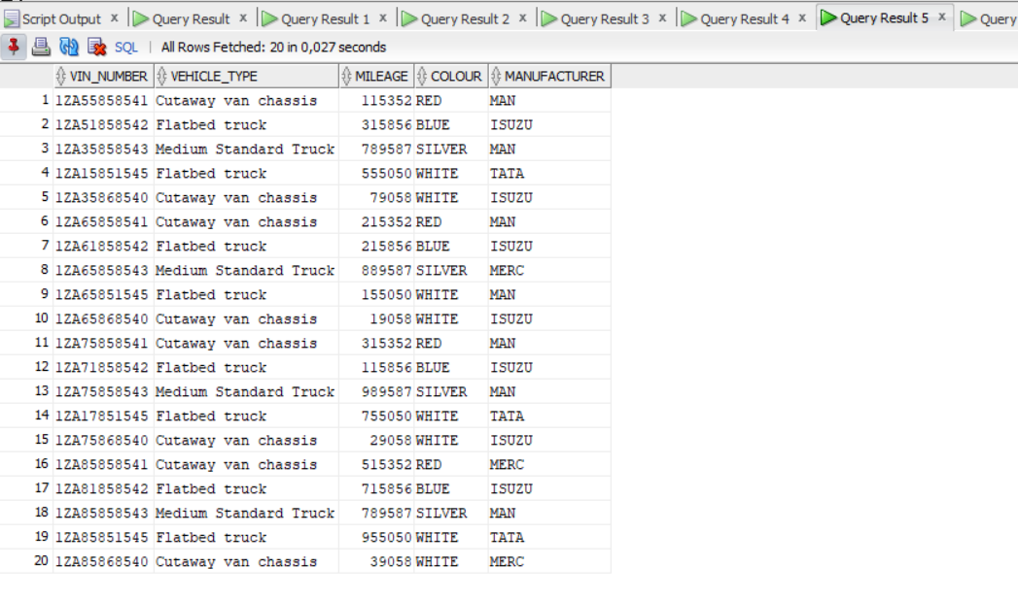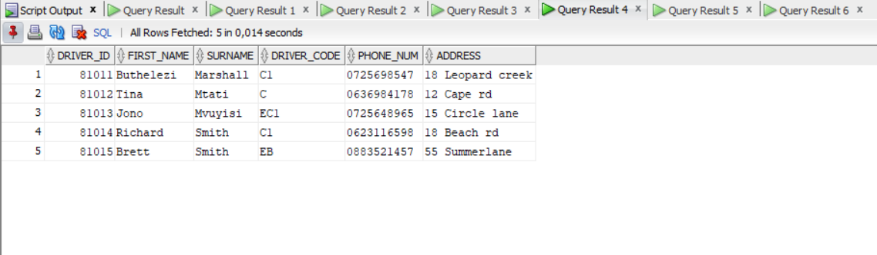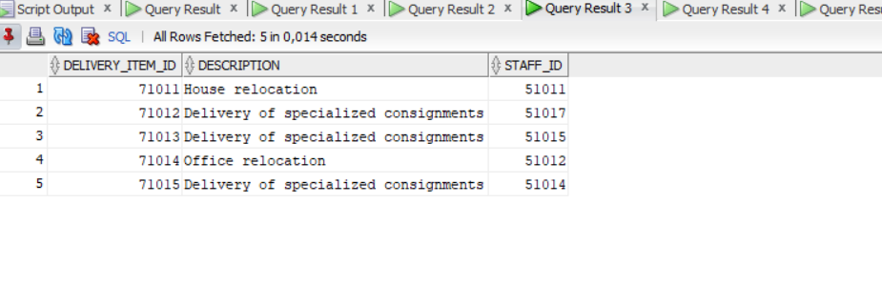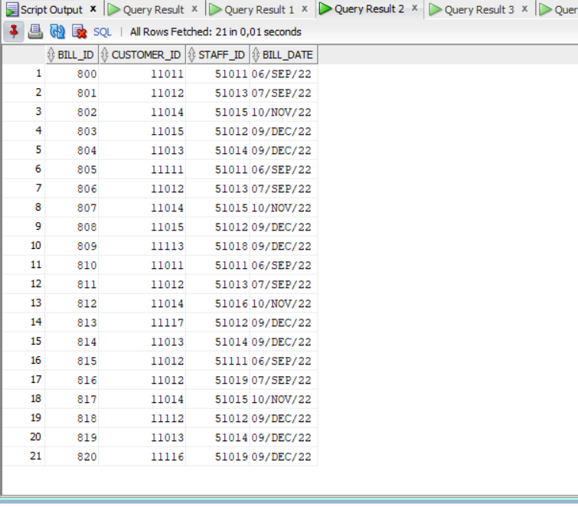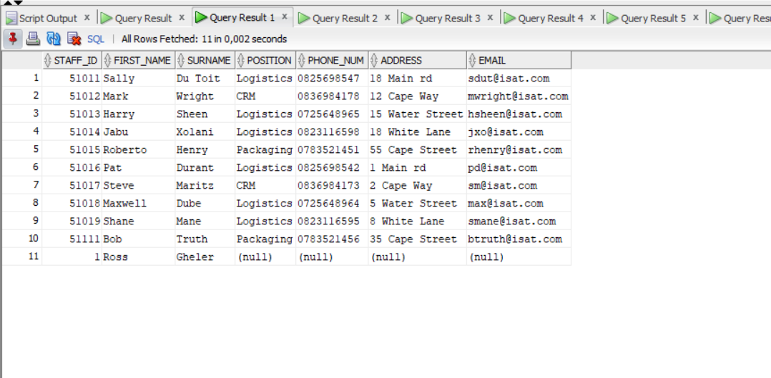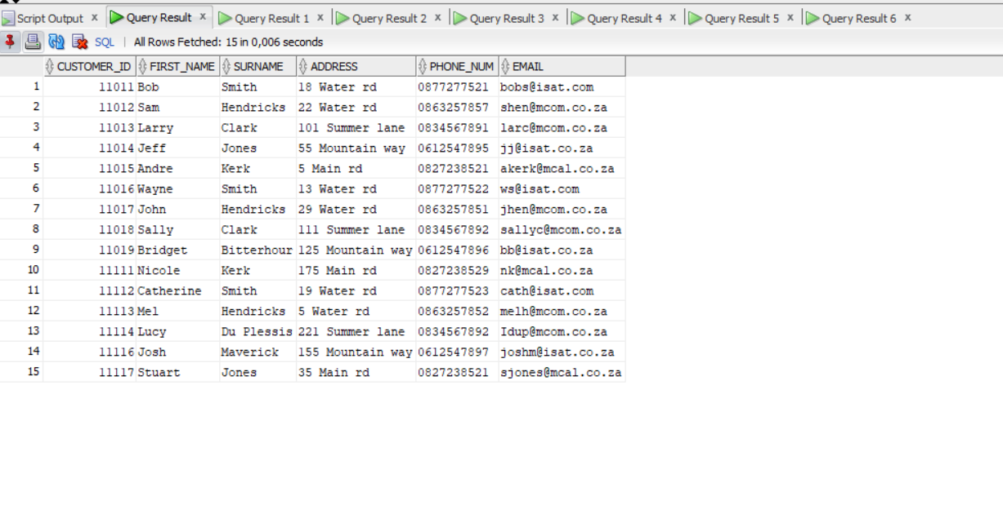

question 3:

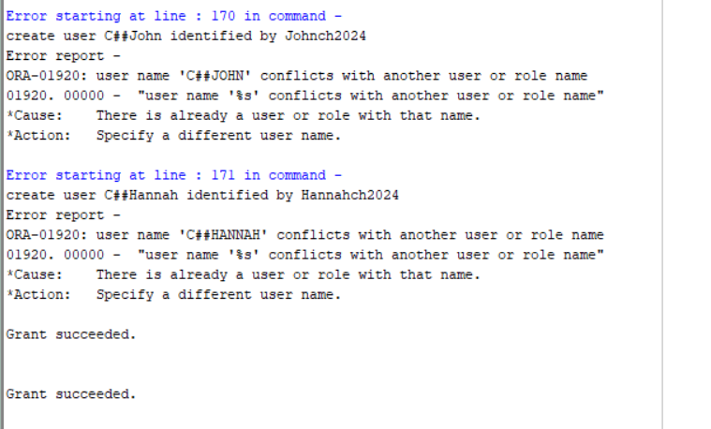

Errors indicate that users john and hannah already exist, privileges granted to them successfully.

Question 4:

Question 5:

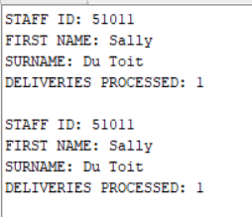

Question 6:

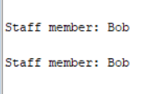

Implicit and explicit

6.2



References:

(No date a) *YouTube*. Available at: <https://www.youtube.com/watch?v=FsVpkamX--Q> (Accessed: 05 September 2024).

(No date b) *Cursor attributes*. Available at: <https://docs.oracle.com/cd/B13789_01/appdev.101/b10807/13_elems011.htm#:~:text=Every%20explicit%20cursor%20and%20cursor,see%20%22Using%20Cursor%20Expressions%22>. (Accessed: 05 September 2024).

*Database PL/SQL language reference* (2024) *Oracle Help Center*. Available at: <https://docs.oracle.com/en/database/oracle/oracle-database/19/lnpls/implicit-cursor-attribute.html#:~:text=An%20implicit%20cursor%20has%20attributes,statements%2C%20not%20in%20SQL%20statements.&text=SQL%25ISOPEN%20always%20has%20the%20value%20FALSE%20>. (Accessed: 05 September 2024).

GeeksforGeeks                                                                                                                                                                                                                                                  and GeeksforGeeks (2023) *SQL: Sequences*, *GeeksforGeeks*. Available at: <https://www.geeksforgeeks.org/sql-sequences/> (Accessed: 05 September 2024).

H                                                                                                                                                                Harsh Agarwal                                                                                *et al.* (2024) *SQL Views*, *GeeksforGeeks*. Available at: <https://www.geeksforgeeks.org/sql-views/> (Accessed: 05 September 2024).

*Inserting multiple rows using a single statement* (no date) *Oracle Live SQL - Script: Inserting Multiple Rows Using a Single Statement*. Available at: <https://livesql.oracle.com/apex/livesql/file/content_BM1LJQ87M5CNIOKPOWPV6ZGR3.html> (Accessed: 05 September 2024).